TNCPI/APPLICATION/SRP/2021/BISA
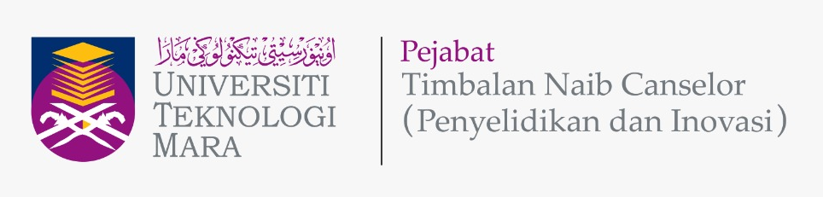

STRATEGIC RESEARCH PARTNERSHIP (SRP) GRANT
UiTM-Universitas Indonesia Bilateral Strategic Alliance
(UiTM-UI BISA) Matching Grant
APPLICATION FORM

Please give attention to the following details:
- The proof of strong existing collaboration, such as joint publication, postgraduate co-supervision, etc., between Universiti Teknologi MARA (UiTM) and Universitas Indonesia (UI) must be attached together with this form during submission.
- The proof of contribution to Tabung Amanah Penyelidikan dan Inovasi UiTM (TAPIU) for Project Leader and all project members from UiTM must be attached together with this form during submission.
- Incomplete form will be rejected.
- This form must be submitted to the Secretariat Research Grant Acquisition Unit (UPG), Research Management Centre (RMC), Aras 3, Bangunan Wawasan, The Office of Deputy Vice Chancellor (Research & Innovation) UiTM Shah Alam.
Email: sekretariatupg@uitm.edu.my; Tel: 03-55448255/8259

A | DETAILS OF THE COLLABORATOR (IHL)
 | IHL Name | UNIVERSITAS INDONESIA (UI)
 | Address

B | PROGRAM APPLICATION DETAILS
 | Program Title
Program Duration
(year/months)
 | Research Cluster  (Please Tick √ ) | Science & Technology
 | Type of Research  (Please Tick √ ) | Fundamental Research |  | Applied Research
 | Research Area  (Please Tick √, choose one (1) only) | Advanced nanomaterials
 |  | Biodiversity and natural resources
 |  | Renewable energy
 |  | Big data analysis
 |  | Green and smart manufacturing.

C | DETAILS OF PROGRAM LEADER
 | Name
 | IC/Passport Number
 | Staff No.
 | Position
 | Faculty/College/Campus/CoE Name & Address
 | Office Telephone No.
 | Hand phone No.
 | Email address

D | INFORMATION OF PROJECTS
 |  | PROJECT 1 (UiTM)  (Registration: International Grant) |  | PROJECT 2 (UI)  (Registration: International Grant)
i. | Project Leader  (Note: Program leader is the Project 1 Leader)
ii. | Title of the Project
iii. | Research Objectives | 1.  2. |  | 1.  2.
iv. | Expected Outcome  (Please Tick √ )  (Each research collaboration program must publish a minimum of two (2) articles in SCOPUS or WOS indexed journals with co-affiliation UiTM and UI, in which one (1) of the articles must be published in Scopus Q1 journal with minimal SJR 0.5.) | Indexed publication in Scopus / WoS |  | Indexed publication in Scopus / WoS
 |  | Indexed publication in Q1 Scopus journal with minima SJR 0.5 |  | Indexed publication in Q1 Scopus journal with minima SJR 0.5
 |  | Postgraduate students to be trained |  | Postgraduate students to be trained
 |  | IPR  (state): ……………………. |  | IPR  (state): …………………….
 |  | Other outcomes  (state): ……………………. |  | Other outcomes  (state): …………………….

E | DETAILS OF PROJECT MEMBERS
 | INTERNAL TEAM MEMBERS (UiTM)
 | No. | Name | Staff No. | IC / Passport | Faculty & Address
 | 1.
 | 2.
 | 3.
 | EXTERNAL TEAM MEMBERS (non-UiTM) (If any)
 | No. | Name | IC / Passport | Institution Name | Address | Email
 | 1.
 | 2.

F | TEAM MEMBERS (UI)
No. | Name | Position | Faculty | Address | Email
1.
2.
3.

G | OVERALL PROGRAM RESEARCH PROPOSAL
Executive Summary (maximum 300 words)
(Please include the summary of research background/significance of study, objectives, research methodology and expected outcomes of the research project)
 | Problem Statement
 | Research Question(s)
Objective(s) of the Program
(Program Objectives 1 & 2: Should refer to the Project Objective(s) in Section D(iii))
Literature Review
(maximum 700 words)
Research Methodology
(Should state role of UiTM and UI)
vii. | References
viii. | Novelty/New Findings/Knowledge

H | PROGRAM RESEARCH ACTIVITY
 | Program Gantt Chart
 | Program Milestone and Dates
 | Description Date Cumulative Project Completion Percentage(%)
 | Flowchart of Program Research Activities

I | BUDGET OF PROJECT
Budget Type |  | Budget Description | UITM  Project 1 (RM) |  | UI  Project 2 (USD)
 |  |  | Year 1 | Year 2 | Year 1 | Year 2
Vote 11000 :
Salary and wages
Vote 21000 :
Travelling expenses and subsistence
Vote 24000 :
Rental
Vote 27000 :
Research Materials & Supplies
Vote 28000 :
Minor Modifications and Repairs
Vote 29000 :
Professional services
Vote 35000 :
Equipment and Accessories
Sub Total Budget (RM)
(Maximum fund from UiTM is USD 4,250 = RM 17,850)
(Maximum fund from UI is USD 4,250 = RM 17,850)
Total Budget (RM)
(Maximum Total fund is USD 8,500 = RM 35,700)

J | FINANCIAL COMMITMENT  (As agreed by both/all parties and clearly stated in MoA)
SRP (PROJECT 1) : TOTAL FUND FROM UITM (RM)
SRP (PROJECT 2) : TOTAL FUND FROM UI (RM)
TOTAL BUDGET (RM)

K | DECLARATION  (Tick √ if applicable)
 | All information stated here are accurate, RMC has right to reject or to cancel the offer without prior notice if there is any inaccurate information given.
 | Application of this research is subjected to the Ethical Committee approval.
 | I hereby declare that this application has fulfill all requirements by Strategic Research Partnership (SRP) Bilateral Strategic Alliance (UI-UiTM BISA) Matching Grant

PROGRAM LEADER NAME
SIGNATURE & STAMP
SUBMISSION DATE

