STRATEGIC RESEARCH PARTNERSHIP (SRP) GRANT
(Industry / Institution / Agency Matching Grant)
TNCPI/APPLICATION/STG/2020
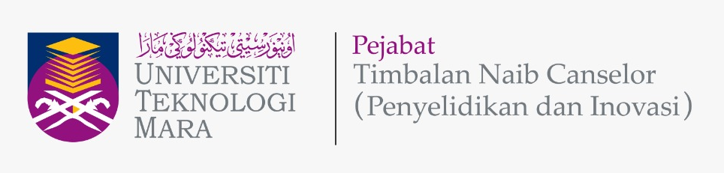

APPLICATION FORM

Please give attention to the following details:
- The proof of contribution to Tabung Amanah Penyelidikan dan Inovasi UiTM (TAPIU) for Project Leader and all project members from UiTM must be attached together with this form during submission.
- The proof of active/strong collaboration with the proposed Industry / Institution / Agency, such as active MoU, must be attached together with this form during submission.
- Incomplete form will be rejected.
- This form must be submitted to Secretariat Research grant acquisition unit (UPG), Research Management Centre (RMC), Aras 3, Bangunan Wawasan, Office Deputy Vice Chancellor (Research & Innovation) UiTM Shah Alam.
Email: upg@uitm.edu.my; Tel: 03-55448255/8259

A | DETAILS OF THE INDUSTRY / INSTITUTION / AGENCY
 | Name
 | Address

B | APPLICATION DETAILS
 | Project Title
Project Duration
(year/months)
 | Research Cluster  (Please Tick √ ) | Science & Technology |  | Social Science
 | Type of Research  (Please Tick √ ) | Fundamental Research |  | Applied Research
 | Research Nexus UiTM (ReNeU)
Centre of Excellence (CoE)
(If any)

C | DETAILS OF PROJECT LEADER
 | Name
 | IC/Passport Number
 | Staff No.
 | Position
 | Faculty
 | Faculty Address
 | Office Telephone No.
 | Hand phone No.
 | Email address

D | DETAILS OF PROJECT MEMBERS
 | INTERNAL TEAM MEMBERS (UiTM)
 | No. | Name | Staff No. | IC / Passport |  | Faculty & Address
 | 1.
 | 2.
EXTERNAL TEAM MEMBERS
(If any)
 | No. | Name | IC / Passport | Institution Name | Address |  | Email | Contact No.
 | 1.
 | 2.

E | DETAILS OF REPRESENTATIVE/COLLABORATOR/PIC FROM THE INDUSTRY/ INSTITUTION / AGENCY
No. | Name | IC / Passport | Industry / Institution / Agency Name | Address | Email | Contact No.
1.
2.

F | RESEARCH PROPOSAL
Executive Summary (maximum 300 words)
(Please include the summary of research background/significance of study, objectives, research methodology and expected outcomes of the research project)
 | Problem Statement
 | Research Question(s)
1.
2.
3.
 | Objective(s) of the Research
1.
2.
3.
 | Literature Review
 | Research Methodology
 | References
 | Novel/New Findings/Knowledge
Expected Output / Outcomes / Implication and Significance of Output from the Research Project
(Eg.: Expected no. of indexed publication / no. of postgraduate students to be trained / MoA / no. of IPR / other outcomes)

G | RESEARCH ACTIVITY
 | Project Gantt Chart
 | Project Milestone and Dates
 | Description Date Cumulative Project Completion Percentage(%)
 | Flowchart of Research Activities

H | BUDGET
Budget Type |  | Budget Description | Total  (RM)
Vote 11000 :
Salary and wages

Vote 21000 :
Travelling expenses and subsistence

Vote 24000 :
Rental

Vote 27000 :
Research Materials & Supplies

Vote 28000 :
Minor Modifications and Repairs

Vote 29000 :
Professional services

Vote 35000 : Equipment and Accessories

Total Budget (RM)

J | FINANCIAL COMMITMENT  (As agreed by both/all parties and clearly stated in MoA)
TOTAL BUDGET (RM)
SRP(U) : TOTAL FUND FROM UiTM (RM)
SRP(I) : TOTAL FUND FROM THE INDUSTRY/INSTITUTION/AGENCY (RM)

K | DECLARATION  (Tick √ if applicable)
 | All information stated here are accurate, RMC has right to reject or to cancel the offer without prior notice if there is any inaccurate information given.
 | Application of this research is subject to Ethical Committee approval.
 | I hereby declare that has fulfilled requirement as required by Strategic Research Partnership (SRP) Grant (Industry/Institution/Agency Matching Grant)

PROJECT LEADER NAME

SIGNATURE & STAMP

SUBMISSION DATE

