Myra ROAD TO HICoE 2021
TNCPI/APPLICATION/HICOE/2021
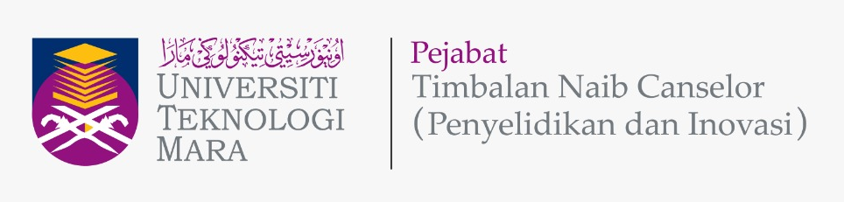

APPLICATION FORM

Please give attention to the following details:
- The proof of contribution to Tabung Amanah Penyelidikan dan Inovasi UiTM (TAPIU) for Project Leader and all project members from UiTM must be attached together with this form during submission.
- Incomplete form will be rejected.
- This form must be submitted to Secretariat Research Grant Acquisition Unit (UPG), Research Management Centre (RMC), Aras 3, Bangunan Wawasan, The Office of Deputy Vice Chancellor (Research & Innovation) UiTM Shah Alam or
Email: sekretariatupg@uitm.edu.my; Tel: 03-55448255/8259

A | APPLICATION DETAILS
 | Project Title
Project Duration
(year/months)
 | Field of Research  (Please Tick √ ) | Science & Technology |  | Social Science
 | Type of Research  (Please Tick √ ) | Fundamental Research |  | Applied Research
 | Research Nexus UiTM (ReNeU)  (Please Tick (√ ) one) | Industrial Technology
 |  | Cyber Technology
 |  | Health & Wellness
 |  | Logistics & Transportation
 |  | Energy & Environment
 |  | Social Creativity & Innovation

B | DETAILS OF PROJECT LEADER
 | Name
 | IC/Passport Number
 | Staff No.
 | Position
 | Faculty/College/Campus/CoE Name & Address
 | Office Telephone No.
 | Hand phone No.
 | Email address

C | DETAILS OF PROJECT MEMBERS
 | INTERNAL TEAM MEMBERS (UiTM)
 | No. | Name | Staff No. | IC / Passport |  | Role of Team Member
 | 1.
 | 2.
 | 3.
EXTERNAL TEAM MEMBERS
(If any)
 | No. | Name | IC / Passport | Institution Name | Email | Role of Team Member
 | 1.
 | 2.
 | 3.

D | RESEARCH PROPOSAL
Executive Summary (maximum 300 words)
(Please include the summary of research background/significance of study, objectives, research methodology and expected outcomes of the research project)
 | Problem Statement
 | Research Question(s)
 | Objective(s) of the Research
 | Literature Review
 | Research Methodology
vii. | References
viii. | Novelty/New Findings/Knowledge
ix. | Expected Output / Outcomes /Implication And Significance of Output From The Research Project

E | PROGRAM RESEARCH ACTIVITY
 | Program Gantt Chart
 | Program Milestone and Dates
 | Description Date Cumulative Project Completion Percentage(%)
 | Flowchart of Program Research Activities

F | BUDGET OF PROJECT
Budget Type |  | Budget Description | Year
 |  |  | Year 1 | Year 2
Vote 11000 :
Salary and wages
Vote 21000 :
Travelling expenses and subsistence
Vote 24000 :
Rental
Vote 27000 :
Research Materials & Supplies
Vote 28000 :
Minor Modifications and Repairs
Vote 29000 :
Professional services
Vote 35000 :
Equipment and Accessories
Sub Total Budget (RM)
Total Budget (RM)

G | DECLARATION  (Tick √ if applicable)
 | All information stated here are accurate, RMC has right to reject or to cancel the offer without prior notice if there is any inaccurate information given.
 | Application of this research is subjected to the Ethical Committee approval.
 | I hereby declare that this application has fulfill all requirements by Road to HICoE MyRA Research Grant.

PROGRAM LEADER NAME
SIGNATURE & STAMP
SUBMISSION DATE

