GLOBAL RESEARCH REPUTATION (GRR) GRANT (International Mobility Research Grant)
TNCPI/APPLICATION/GRR/2020
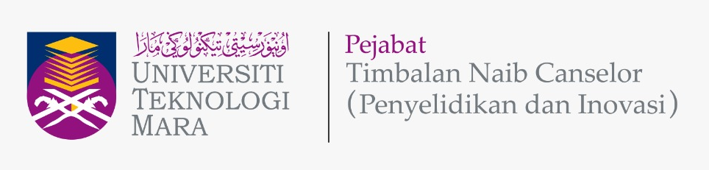

APPLICATION FORM

Please give attention to the following details:
- The proof of contribution to Tabung Amanah Penyelidikan dan Inovasi UiTM (TAPIU) for Project Leader and all project members from UiTM must be attached together with this form during submission.
- The proof of active/strong collaboration with the proposed International Institution, such as an active MoU or joint publication, must be attached together with this form during submission. The proposed international institution must be ranked top 100 in the latest QS World University rankings.
- Incomplete form will be rejected.
- This form must be submitted to Secretariat Research grant acquisition unit (UPG), Research Management Centre (RMC), Aras 3, Bangunan Wawasan, Office Deputy Vice Chancellor (Research & Innovation) UiTM Shah Alam.
Email: upg@uitm.edu.my; Tel: 03-55448255/8259

A | DETAILS OF THE INTERNATIONAL INSTITUTION
 | Name
 | Address

B | APPLICATION DETAILS
 | Program Title
Program Duration
(Year/Months)
 | Research Cluster  (Please Tick √ ) | Science & Technology |  | Social Science
 | Type of Program Goals  (Tick √ all appropriate Goals) | Scopus/WoS Indexed Journal Publications
 |  | Publication in Q1/Q2 JCR Journal(s)
 |  | MoU / MoA documents & signing
 |  | International Grant Proposal preparation and submission
Other goals: (Please specify)
- ____________________________________________
- ____________________________________________
- ____________________________________________

 | Research Nexus UiTM (ReNeU)
Centre of Excellence (CoE)
(If any)

C | DETAILS OF PROJECT LEADER
 | Name
 | IC/Passport Number
 | Staff No.
 | Position
 | Faculty
 | Faculty Address
 | Office Telephone No.
 | Hand phone No.
 | Email address

D | DETAILS OF PROJECT MEMBERS
 | INTERNAL TEAM MEMBERS (UiTM)
 | No. | Name | Staff No. | IC / Passport |  | Faculty & Address
 | 1.
 | 2.
EXTERNAL TEAM MEMBERS
(If any)
 | No. | Name | IC / Passport | Institution Name | Address |  | Email | Contact No.
 | 1.
 | 2.
 | INTERNATIONAL INSTITUTION/COLLABORATOR TEAM MEMBERS
 | No. | Name | IC / Passport | Institution Name | Address |  | Email | Contact No.
 | 1.
 | 2.

E | DETAILS OF THE COLLABORATION PROGRAM
Executive Summary of the program (maximum 300 words)
(Please include the summary of program background/significance of the program, objectives, methodology and expected outcomes of the program)
 | Collaboration Background
 | Collaboration Objective(s)
1.
2.
3.
 | Details of Collaboration Program and Timeline
Flow Chart of Program Activities
• Attach Gantt Chart of Program Activities with Milestones
Expected Program Outcomes / Implication and Significance of Output from the Program
• Impact Statement (to the visibility/benefits of UiTM)
• Collaborative Research Publications
• Collaborative International research Grant Application title

F | BUDGET
Budget Type |  | Budget Description | Total  (RM)
Vote 21000 :
Travelling expenses and subsistence

Vote 27000 :
Research Materials & Supplies

Vote 29000 :
Professional services

TOTAL BUDGET (RM)

G | DECLARATION  (Tick √ if applicable)
 | All information stated here are accurate, RMC has right to reject or to cancel the offer without prior notice if there is any inaccurate information given.
 | I hereby declare that has fulfilled requirement as required by Global Research Reputation (GRR) (International Mobility Research Grant)

PROJECT LEADER NAME

SIGNATURE & STAMP

SUBMISSION DATE

