STRATEGIC RESEARCH PARTNERSHIP (SRP) GRANT
(Industry/Agency)
APPLICATION FORM
TNCPI/APPLICATION/SRP/2022
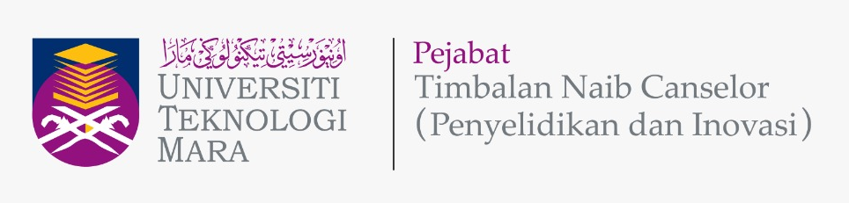

Please give attention to the following details:
- Incomplete application form will be rejected.
- The proof of contribution to Tabung Amanah Penyelidikan dan Inovasi UiTM (TAPIU) for Project Leader and all project members from UiTM must be attached to this form during submission.
- This form must be submitted to Secretariat Research Grant Acquisition Unit (UPG), Research Management Centre (RMC), Aras 3, Bangunan Wawasan, The Office of Deputy Vice Chancellor (Research & Innovation) UiTM Shah Alam.
Email: sekretariatupg@uitm.edu.my; Tel: 03-55448255/8259

A | DETAILS OF THE COLLABORATOR (INDUSTRY / AGENCY)
 | Industry / Agency Name
 | Address

B | PROGRAM APPLICATION DETAILS
 | Program Title
Program Duration
(max 2 years)
 | Research Cluster | Science & Technology |  | Science Social
 | Type of Research  (Please Tick √ ) | Fundamental Research |  | Applied Research
 | Research Area  (Please Tick √, choose one (1) only) | Industrial Technology
 |  | Cyber Technology
 |  | Health & Wellness
 |  | Logistics & Transportation
 |  | Energy & Environment
 |  | Social Creativity & Innovation

C | PROJECTS DETAILS
 |  | PROJECT 1  (Note: Fund from the University, Registration: University Grant) |  | PROJECT 2  (Note: Fund received from Industry/Agency, Registration: PRI/GOV/INT Grants)
i. | Project Leader | ……………………………………………… |  | ………………………………………………  (Note: Fill up this space if Project 2 is to be led by another UiTM’s project member)
ii. | Title of the Project
iii. | Research Objectives | 1.  2. |  | 1.  2.
iv. | Expected Outcome  (Please Tick √ )  (Each project MUST publish a minimum of one (1) journal article indexed in Scopus/WoS) | One (1) journal article indexed in Scopus/WoS | √ | One (1) journal article indexed in Scopus/WoS | √
 |  | Postgraduate students to be trained |  | Postgraduate students to be trained
 |  | Article in proceedings  (state): ……………………. |  | Article in proceedings  (state): …………………….
 |  | IPR  (state): ……………………. |  | IPR  (state): …………………….
 |  | Other outcomes  (state): ……………………. |  | Other outcomes  (state): …………………….

D | DETAILS OF PROJECT LEADER & MEMBERS
D1 | DETAILS OF PROJECT LEADER FOR PROJECT 1
 | Name of Project Leader
 | IC/Passport Number
 | Staff No.
 | Position
 | Faculty/College/Campus/CoE Name & Address
 | Office Telephone No.
 | Hand phone No.
 | Email address
 | Research Expertise
D2 | DETAILS OF PROJECT LEADER FOR PROJECT 2  (Note: Do not fill up this subsection if Leader of Project 1 is similar to Project 2)
 | Name of Project Leader
 | IC/Passport Number
 | Staff No.
 | Position
 | Faculty/College/Campus/CoE Name & Address
 | Office Telephone No.
 | Hand phone No.
 | Email address
 | Research Expertise
D3 | DETAILS OF PROJECT MEMBERS
 | INTERNAL TEAM MEMBERS (UiTM)
 | No. | Name | Staff No. | IC / Passport | Faculty & Address |  | Email
 | 1.
 | 2.
 | EXTERNAL TEAM MEMBERS (NON-UiTM INCLUDING COLLABORATOR/INDUSTRY/AGENCY) (If any)
 | No. | Name | IC / Passport | Institution/ Collaborator Name | Address | Email
 | 1.
 | 2.

F | OVERALL PROGRAM RESEARCH PROPOSAL
Executive Summary (maximum 300 words)
(Please include the summary of research background/significance of study, objectives, research methodology and expected outcomes of the research project)
 | Problem Statement
 | Research Question(s)
Objective(s) of the Program
(Program Objectives 1 & 2: Should refer to the Project Objective(s) in Section C(iii))
Literature Review
(maximum 700 words)
 | Research Methodology
vii. | References
viii. | Novelty/New Findings/Knowledge

G | PROGRAM RESEARCH ACTIVITY
 | Program Gantt Chart
 | Program Milestone and Dates
 | Description Date Cumulative Project Completion Percentage(%)
 | Flowchart of Program Research Activities

H | BUDGET OF PROJECT
Budget Type |  | Budget Description | PROJECT 1  (Note: Fund from the University, Registration: University Grant) |  | PROJECT 2  (Note: Fund received from Industry/Agency, Registration: PRI/GOV/INTl Grants)
 |  |  | Year 1 | Year 2 | Year 1 | Year 2
Vote 11000 :
Salary and wages
Vote 21000 :
Travelling expenses and subsistence
Vote 24000 :
Rental
Vote 27000 :
Research Materials & Supplies
Vote 28000 :
Minor Modifications and Repairs
Vote 29000 :
Professional services
Vote 35000 :
Equipment and Accessories
Sub Total Budget (RM)

I | FINANCIAL COMMITMENT  (As agreed by both parties and clearly stated in MoA)
SRP (PROJECT 1) : TOTAL FUND FROM UiTM
SRP (PROJECT 2) : TOTAL FUND FROM INDUSTRY/AGENCY

J | DECLARATION  (Tick √ if applicable)
 | All information stated here is accurate, RMC has the right to reject or to cancel the offer without prior notice if there is any inaccurate information given.
 | Application of this research is subject to the Ethical Committee approval.
 | I hereby declare that this application has fulfill all requirements by Strategic Research Partnership (SRP) Grant

NAME OF PROJECT LEADER
SIGNATURE & STAMP
SUBMISSION DATE

