STRATEGIC RESEARCH PARTNERSHIP (SRP) GRANT
Bilateral Strategic Alliance 2.0 (UI-UiTM BISA 2.0)
Matching Grant

TNCPI/APPLICATION/SRP/2022
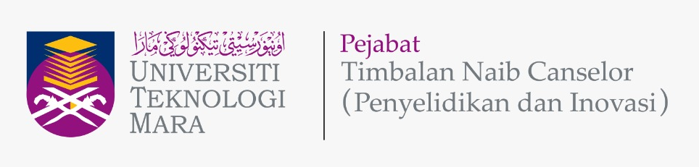

APPLICATION FORM
Please give attention to the following details:
- Incomplete application form will be rejected.
- The proof of contribution to Tabung Amanah Penyelidikan dan Inovasi UiTM (TAPIU) for Project Leader and all project members from UiTM must be attached to this form during submission.
- This form must be submitted to Secretariat Research Grant Acquisition Unit (UPG), Research Management Centre (RMC), Aras 3, Bangunan Wawasan, The Office of Deputy Vice Chancellor (Research & Innovation) UiTM Shah Alam.
Email: sekretariatupg@uitm.edu.my; Tel: 03-55448255/8259

A | DETAILS OF THE COLLABORATOR (INSTITUTION OF HIGHER LEARNING, (IHL))
 | IHL Name | Universitas Indonesia (UI)
 | Address

B | PROGRAM APPLICATION DETAILS
 | Program Title
Program Duration
(max 2 years)
 | Research Cluster  (Please Tick √ ) | Social Science
 | Type of Research  (Please Tick √ ) | Fundamental Research |  | Applied Research
 | Research Area  (Please Tick √, choose one (1) only) | Circular and sustainable economy
 |  | Cultural preservation and science-integrated local wisdom
 |  | Sustainable urban development
 |  | Sustainable logistics and supply chain
 |  | Psychological Impact of COVID-19

C | PROJECTS DETAILS
 |  | PROJECT 1 (UiTM)  (Registration: International Grant)) |  | PROJECT 2 (UI)  (Registration: International Grant))
i. | Project Leader
ii. | Title of the Project
iii. | Research Objectives | 1.  2. |  | 1.  2.
iv. | Expected Outcome  (Please Tick √ )  (Each project from UiTM and UI MUST publish a minimum of one (1) Q3 journal article indexed in Scopus | One (1) article in Q3 ranked Scopus journal |  | One (1) article in Q3 ranked Scopus journal
 |  | Postgraduate students to be trained |  | Postgraduate students to be trained
 |  | Article in proceedings  (state): ……………………. |  | Article in proceedings  (state): …………………….
 |  | IPR  (state): ……………………. |  | IPR  (state): …………………….
 |  | Other outcomes  (state): ……………………. |  | Other outcomes  (state): …………………….

D | DETAILS OF PROJECT LEADER & MEMBERS FROM UiTM
D1 | DETAILS OF PROJECT LEADER
 | Name of Project Leader
 | IC/Passport Number
 | Staff No.
 | Position
 | Faculty/College/Campus/CoE Name & Address
 | Office Telephone No.
 | Handphone No.
 | Email address
 | Research Expertise
D2 | DETAILS OF PROJECT MEMBERS
 | INTERNAL TEAM MEMBERS (UiTM)
 | No. | Name | Staff No. | IC / Passport | Faculty & Address |  | Email
 | 1.
 | 2.
 | EXTERNAL TEAM MEMBERS (non-UiTM) (If any)
 | No. | Name | IC / Passport | Institution Name | Address | Email
 | 1.
 | 2.

E | DETAILS OF PROJECT LEADER & MEMBERS FROM UI
E1 | DETAILS OF PROJECT LEADER
 | Name of Project Leader
 | IC/Passport Number
 | Staff No.
 | Position
 | Faculty/College/Campus/CoE Name & Address
 | Office Telephone No.
 | Handphone No.
 | Email address
 | Research Expertise
E2 | DETAILS OF PROJECT MEMBERS
 | INTERNAL TEAM MEMBERS (UI)
 | No. | Name | Staff No. | IC / Passport | Faculty & Address |  | Email
 | 1.
 | 2.
 | EXTERNAL TEAM MEMBERS (non-UI) (If any)
 | No. | Name | IC / Passport | Institution Name | Address | Email
 | 1.
 | 2.

F | OVERALL PROGRAM RESEARCH PROPOSAL
Executive Summary (maximum 300 words)
(Please include the summary of research background/significance of study, objectives, research methodology and expected outcomes of the research project)
 | Problem Statement
 | Research Question(s)
Objective(s) of the Program
(Program Objectives 1 & 2: Should refer to the Project Objective(s) in Section C(iii))
Literature Review
(maximum 700 words)
Research Methodology
(Should state role of UiTM and UI)
vii. | References
viii. | Novelty/New Findings/Knowledge

G | PROGRAM RESEARCH ACTIVITY
 | Program Gantt Chart
 | Program Milestone and Dates
 | Description Date Cumulative Project Completion Percentage(%)
 | Flowchart of Program Research Activities

H | BUDGET OF PROJECT
Budget Type |  | Budget Description | UITM  Project 1 |  | UI  Project 2
 |  |  | Year 1 | Year 2 | Year 1 | Year 2
Vote 11000 :
Salary and wages
Vote 21000 :
Traveling expenses and subsistence
Vote 24000 :
Rental
Vote 27000 :
Research Materials & Supplies
Vote 28000 :
Minor Modifications and Repairs
Vote 29000 :
Professional services
Vote 35000 :
Equipment and Accessories
Sub Total Budget (RM)

I | FINANCIAL COMMITMENT  (As agreed by both parties and clearly stated in MoA)
SRP (PROJECT 1): TOTAL FUND FROM UiTM (RM) (Max. RM 20,000)
SRP (PROJECT 2): TOTAL FUND FROM UI (Rp.) (Max. Rp. 68.000.000)

J | DECLARATION  (Tick √ if applicable)
 | All information stated here is accurate, RMC has the right to reject or to cancel the offer without prior notice if there is any inaccurate information given.
 | Application of this research is subject to the Ethical Committee approval.
 | I hereby declare that this application has fulfilled all requirements by Strategic Research Partnership (SRP) Grant

NAME OF PROJECT LEADER FROM UiTM
SIGNATURE & STAMP
SUBMISSION DATE

